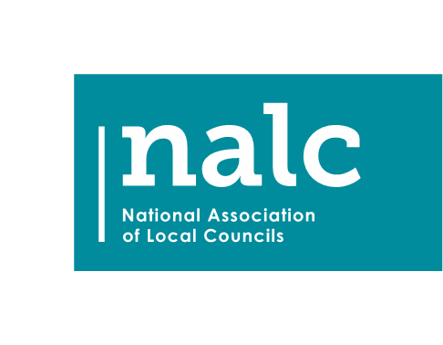
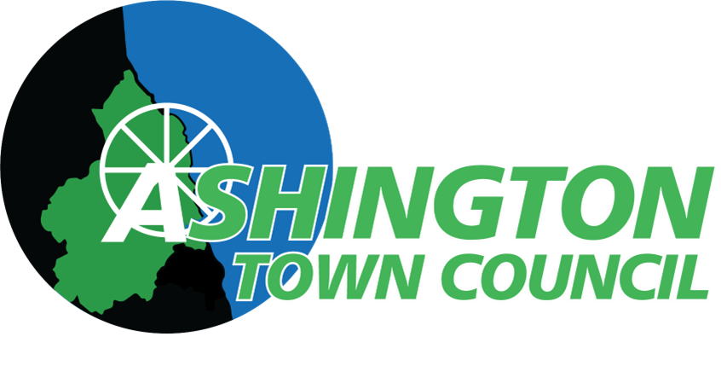

WHISTLEBLOWING POLICY

This document was commissioned by the National Association of Local Councils (NALC) for the purpose of its member councils and county associations. Every effort has been made to ensure that the contents of this document are correct at time of publication. NALC cannot accept responsibility for errors, omissions and changes to information subsequent to publication.
The Executive Officer has updated the document in keeping with recent legislative changes in respect of the Employment Rights Act 2025.

Contents
Whistleblowing Policy 3
1. Purpose of Policy 3
2. Background 3
3. Principles 3
4. Procedure 4
Stage 1 4
Stage 2 5
Stage 3 5
5. Data Protection 5
6. Monitoring and Review Of This Policy 5

This Whistleblowing Policy was adopted by the council at its meeting held on 26th May 2026. Reviewed and updated May 2026 to reflect the Employment Rights Act 2025.

Whistleblowing Policy

Purpose of Policy
It is important that any fraud, misconduct or wrongdoing by staff or others working on behalf of the council is reported and properly dealt with. We therefore require all individuals to raise any concerns that they may have about the conduct of others in the council. This policy sets out the way in which individuals may raise any concerns that they have and how those concerns will be dealt with.

Background
The Public Interest Disclosure Act 1998 amended the Employment Rights Act 1996 to provide protection for workers who raise legitimate concerns about specified matters in the public interest. These are called "qualifying disclosures". A qualifying disclosure is one made by an employee who has a reasonable belief that:
- a criminal offence;
- a miscarriage of justice;
- an act creating risk to health and safety;
- an act causing damage to the environment;
- a breach of any other legal obligation; or
- concealment of any of the above;
- sexual harassment in the workplace;
is being, has been, or is likely to be, committed. It is not necessary for you to have proof that such an act is being, has been, or is likely to be, committed - a reasonable belief is sufficient. You have no responsibility for investigating the matter - it is the council’s responsibility to ensure that an investigation takes place.
If you make a protected disclosure you have the right not to be dismissed, subjected to any other detriment, or victimised, because you have made a disclosure. We encourage you to raise your concerns under this procedure in the first instance.
The Employment Rights Act 2025 expressly provides that a disclosure relating to sexual harassment in the workplace constitutes a protected disclosure for whistleblowing purposes. This means that any worker who reports sexual harassment — whether it has occurred, is occurring, or is likely to occur — is entitled to the full protections of this policy and the underlying legislation, including protection from dismissal, detriment, or victimisation. This protection applies whether the disclosure is made internally under this procedure or externally to a prescribed person or body.

Principles
- Everyone should be aware of the importance of preventing and eliminating wrongdoing at work. Staff and others working on behalf of the council should be watchful for illegal or unethical conduct and report anything of that nature that they become aware of.
- Any matter raised under this procedure will be investigated thoroughly, promptly and confidentially, and the outcome of the investigation reported back to the person who raised the issue.
- No employee or other person working on behalf of the council will be victimised for raising a matter under this procedure. This means that the continued employment and opportunities for future promotion or training of the worker will not be prejudiced because they have raised a legitimate concern.
- The council will not use, or seek to rely on, any non-disclosure agreement (NDA), confidentiality clause, or settlement term that would prevent or restrict a worker from making a protected disclosure. Under the Employment Rights Act 2025, any contractual term that purports to prevent a worker from making a protected disclosure about sexual harassment, or any other qualifying matter, is void and unenforceable. Workers are entitled to ignore any such clause and make a disclosure under this policy without fear of legal action from the council.
- A worker always has the right to make a protected disclosure to their legal adviser when seeking legal advice. This right cannot be restricted by any agreement or instruction.
- Victimisation of an individual for raising a qualified disclosure will be a disciplinary offence.
- If misconduct is discovered as a result of any investigation under this procedure our disciplinary procedure will be used, in addition to any appropriate external measures.
- Maliciously making a false allegation is a disciplinary offence.
- An instruction to cover up wrongdoing is itself a disciplinary offence. If told not to raise or pursue any concern, even by a person in authority such as a manager, you should not agree to remain silent. You should report the matter to the Executive Officer or the Chair of the Council.

Procedure
If you believe a Councillor has breached the councillor Code of Conduct, then raise it with the Chair of the Council. Concerns relating to an alleged breach of the councillor Code of Conduct will be referred to the Monitoring Officer for investigation.
This procedure is for disclosures about matters other than a breach of your own contract of employment, which should be raised via the Grievance Procedure.

Stage 1
In the first instance, any concerns should be raised with the Executive Officer, who will arrange an investigation of the matter. The investigation may involve you and other individuals involved giving a written statement. Any investigation will be carried out in accordance with the principles set out above. Your statement will be taken into account, and you will be asked to comment on any additional evidence obtained.
The Executive Officer (or delegated officer) will take any necessary action, including reporting the matter to the Council, or any appropriate government department or regulatory agency. The Executive Officer (or delegated officer) will also invoke any disciplinary action if required. On conclusion of any investigation, insofar as confidentiality allows, you will be told the outcome and what the council has done, or proposes to do, about it. If no action is to be taken, the reason for this will be explained.

Stage 2
If you are concerned that the Executive Officer is involved in the wrongdoing, has failed to make a proper investigation or has failed to report the outcome of the investigations to the relevant person, you should escalate the matter to the Chair of the Council. The Chair will arrange for a review of the investigation to be carried out, make any necessary enquiries.

Stage 3
If on conclusion of stages 1 and 2 you reasonably believe that the appropriate action has not been taken, you should report the matter to the relevant body. This includes:
- HM Revenue & Customs
- The Health and Safety Executive
- The Environment Agency
- The Serious Fraud Office
- The Charity Commission
- The Pensions Regulator
- The Information Commissioner
- The Financial Conduct Authority
You can find the current list of prescribed persons on the government website at: www.gov.uk/government/publications/blowing-the-whistle-list-of-prescribed-people-and-bodies--2

Data Protection
When an individual makes a disclosure, we will process any personal data collected in accordance with the data protection policy. Data collected from the point at which the individual makes the report is held securely and accessed by, and disclosed to, individuals only for the purposes of dealing with the disclosure. The identity of a person making a disclosure will be kept confidential where possible. Where it is necessary to reveal the identity of the person making the disclosure, this will be discussed with them in advance wherever practicable. Personal data relating to whistleblowing disclosures is processed under the Data Protection Act 2018 and the Data (Use and Access) Act 2025, and is treated as sensitive information throughout.

Monitoring and Review Of This Policy
The Executive Officer shall be responsible for reviewing this policy annually, or sooner if there are significant legislative changes, to ensure that it meets legal requirements and reflects best practice.
Any proposed amendments to this policy shall be reported to and approved by the Council.

