Chair’s Round-Up

Introduction
We have just passed the end of the financial year for the Council, and we are moving into a new Council year. This is marked by the Annual Meeting of the Council, being held on Tuesday 16th May 2023, starting at 6:00pm. This meeting agrees the Chair for the coming year, so now seemed a good time for me to reflect on the year past and offer some insights into the year ahead.

Priorities
The Council is focused on formally implementing some key priorities into our planning. We already recognise these in our spending plans and commitments, so they are becoming embedded in all that we do. They are:
- Keeping the town’s streets and estates clean and litter free.
- Taking urgent action to fight the effects of Climate Change.
- Supporting the community via events, engagement, and grant funding.
- Improving the environment by providing a pleasant and safe place to live.

Cleaner Streets
We continue to provide enhanced street cleansing and a rapid response to fly-tipping via a Service Level Agreement with Northumberland County Council. This delivers enhanced street cleansing and kerb sweeping, a more dedicated presence in high footfall areas, and a rapid response to illegal fly-tipping.
Ashington may boast 420 public litter bins, but litter is still an issue in the town. The Council has a programme of replacing older litter bins with updated models which improves the appearance of streets. We have also removed all post mounted bins which have a smaller capacity and are less accessible.
The Council would prefer to direct funding that is spent on litter and fly-tipping to more positive projects, and we champion those initiatives that encourage people to take pride in their place.
Ashington Community Litter Pickers are out in force regularly and have received funding from the Council for equipment, as well as ongoing support to help co-ordinate their efforts. We supported a ‘Love Where You Live’ campaign in January, and the more recent ‘Great British Spring Clean’.
Allotments may not come under streets, but in terms of clearing-up and clearing-out, the Council has funded some major work this council year to improve the appearance and performance of allotments. This includes water systems, fencing, major clearances, skips, and roadways. There is still work to do and we are working closely with Allotment Associations to make this happen.

Fighting the effects of Climate Change
Where to start with the Council’s action to fight the effects of Climate Change. In the last council year we have changed to an electric van, planted sustainable planting in the large formal beds on Station Road/Gateways, hosted Great Big Green week, planted trees, and set a tree planting target, instigated member, and officer training in Carbon Literacy, installed improved water systems on our allotments, and adopted a working from home policy.
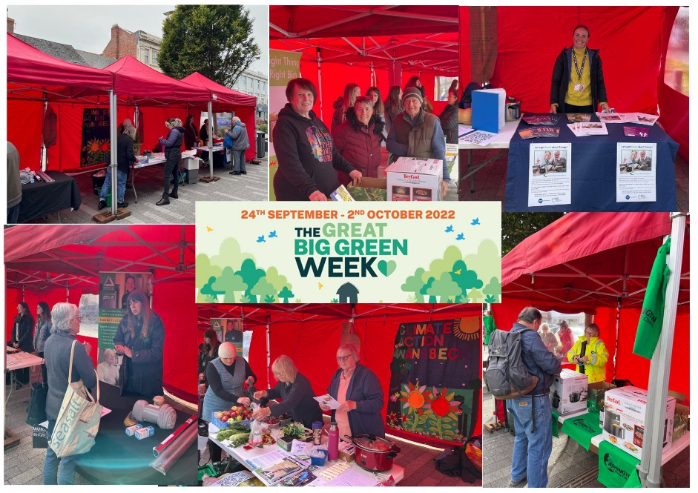
Great Big Green Week was a huge success in 2022. The event for 2023 is in the planning process as we speak. We won’t have as many ‘free giveaways’ in 2023 as we take a lead from those who warn against the impact on carbon footprint, but there will be some great prizes. See us at Ashington Market on Station Road on Tuesday 13th June alongside the usual traders, and other Green Organisations.

Have a look at our tree planting target on the Council’s website. As well as recording the trees planted by the Council, we invited the rest of Ashington to tell us about their own tree planting. Over the last 2 ½ years, 945 trees have been planted in Ashington. There are probably more; if you or someone you know has planted a tree, let us know and we will add it to the map.
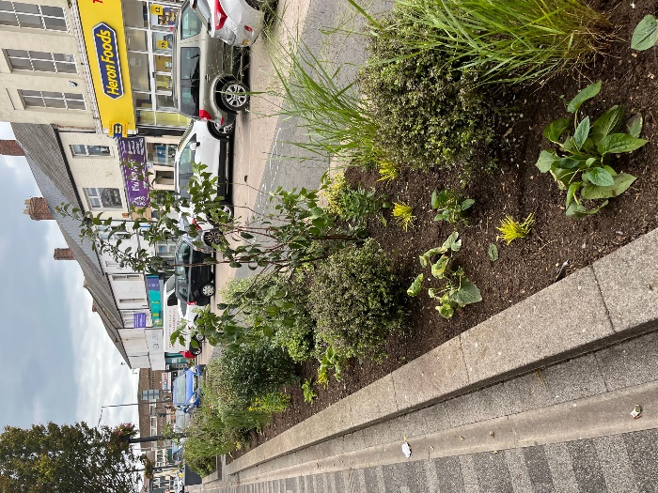
Changing vibrant paintbox coloured formal bedding to sustainable planting is not everyone’s preference, and there is a time and a place for both. We are very proud of the Council’s efforts to reduce the waste and watering associated with maintaining seasonal planting, and the environmental and biodiversity benefits of sustainable planting. Station Road and the town’s Gateways are three quarters through their first year of sustainable planting. They are beginning to take shape and with some further suggestions from local landscape designer Sean Murray, we are excited to see the changes over the coming seasons. Have a look at the project developing in our video on the website, Sensational Sustainable Planting

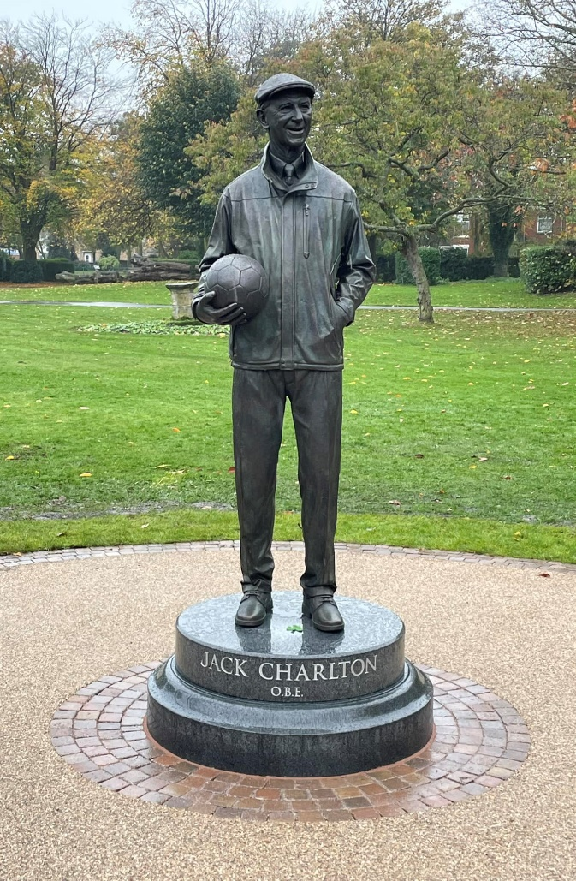
Events, Engagement and Funding
This area of work from the Council will go from strength to strength as Sharon is able to concentrate energies in the role of Communication and Engagement Officer, and the newly formed Events Advisory Group takes shape.
The Jack Charlton Statue and Ashington’s Footballing Heritage Project culminated in an event on 29th October where crowds gathered to watch the unveiling. Residents of Ashington and fans of Jack from much further afield were overwhelmed with the likeness of ‘Jack the Elder.’ I was honoured to witness this fantastic undertaking from start to finish and to see the pride and emotion of his close family and friends, as well as the gathered crowds. The works stand as a legacy to Jack and our footballing heroes. Young teams from across Northumberland took part in a football festival on the same day. A similar event is planned in the coming months, but hopefully with much better weather.
The weather is a common theme for outdoor events, and the Ashington Gardens Competition; there are few who talk more about the weather than gardeners!
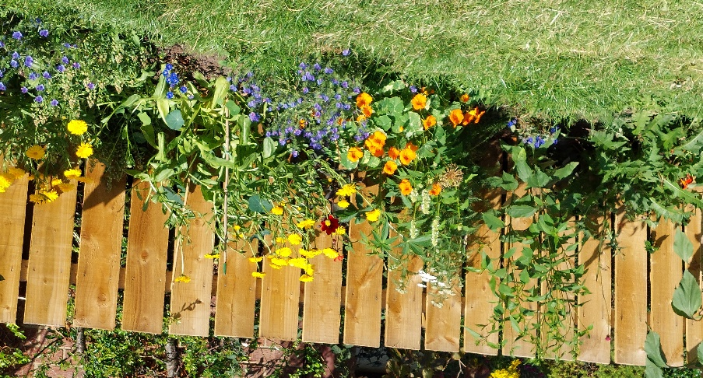
As a tribute to the late Cllr Avril Chisolm there was a special award for ‘Best Sustainable Planting’ which was won by Grace Downie who also won ‘Best Large Garden.’

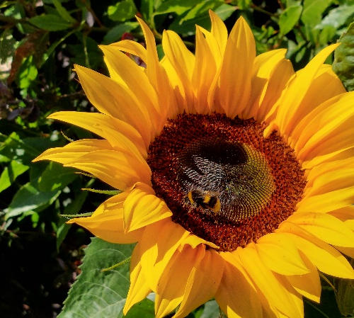
The number of entries has become fewer over the years, sadly, the competition will not feature in the Council’s events calendar of 2023, however you can still enjoy the amazing gardens that entered by watching the video on our website linked above.
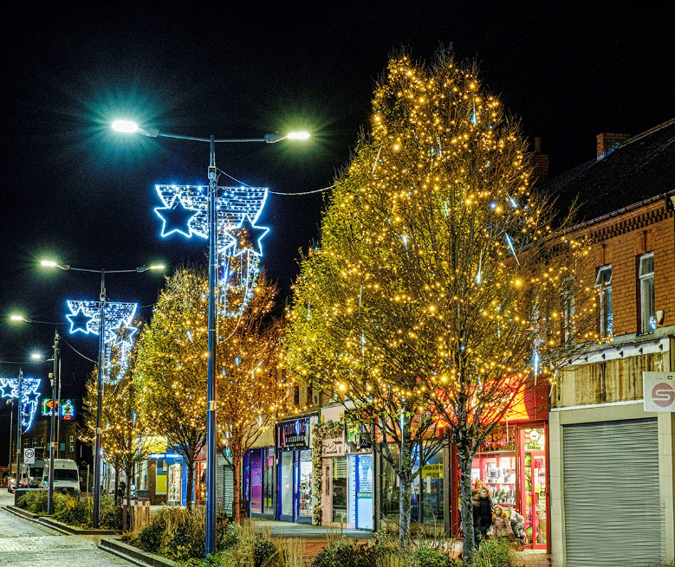
The Christmas Lights switch-on event was cancelled in November due to high winds. This was extremely disappointing following the months of planning, support from local community groups, and businesses who dressed their windows.
Residents remained in high spirits as they were wowed by the new lighting displays and collected selection boxes having done the Christmas trail.
The Council received lots of compliments on the Christmas Light displays for 2022 and have a few extras planned for 2023.
Easter has just passed, and the Council supported the first ‘Bunny Hop.’ Families were invited to take part in an Easter trail around the shops, receiving an Easter Egg on completion. The Council worked with local traders and Ashington Library to deliver this activity, which is another great example of partnership working.
Ashington Town Council considers itself a very generous Council, and we continue to support community groups who enrich the town, and support residents with the impact of the cost-of-living crisis. We awarded £81k in grants last year and increased this to £100k in the current financial year.
If you enjoy reading good news stories, follow us on Facebook to see how grant funding is spent, as the groups we support are incredibly grateful, and regularly share their successes with us, which we can then share with you.

Improving the Environment
We recognise that improving the environment is not only about how the place looks but about enjoying where you live and feeling safe.
Upgrading and improving bus shelters is a positive step with an eye on promoting more sustainable travel. We have replaced three bus shelters and installed four new shelters this year; three of which are scheduled to be installed in May. The investment in bus shelters continues next year with a further three shelters ordered already. As well as looking much fresher, we hope greater access to bus shelters will increase the use of public transport.
Our bus shelters are on a rolling programme of cleansing, and repairs, which are sadly increasing, are carried out quickly.
Enjoyment is investment in play areas which we have planned for the next 10+ years.

Alexandra Road Play Area was transformed in November and plays areas at Aintree Close and Epsom Drive will be redeveloped in July this year.
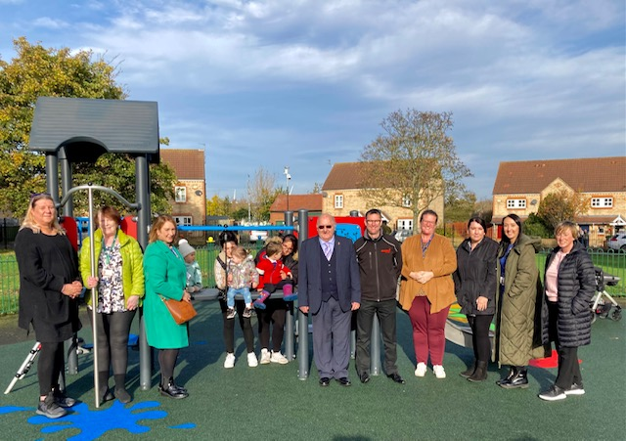
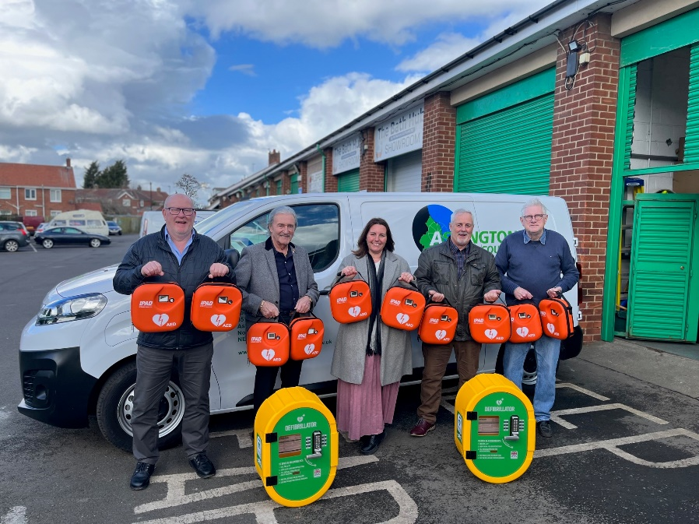
Feeling safe is important to residents and we have installed more CCTV to combat the effects of crime and vandalism. We have also recently purchased and installed twelve public access defibrillators around the town. This is a huge investment thanks to funding from fellow County Cllrs. Public access defibrillators are there in the event of a cardiac emergency and the nearest locations are advised by call handlers by ringing 999. All our defibrillators are listed with emergency services and can be accessed in the event of a cardiac emergency.
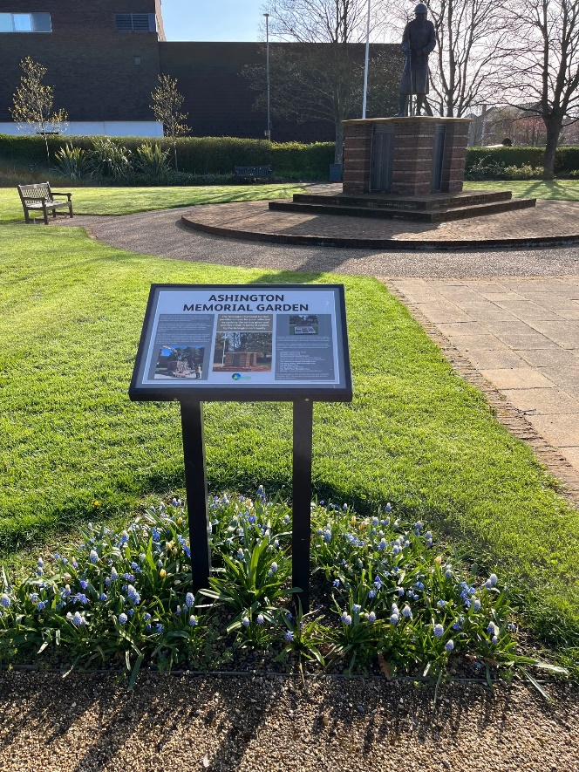
Our Neighbourhood Services Officers work extremely hard all year round to ensure the assets of Ashington Town Council are well looked after. In the coming weeks you will see lots of pre-summer activity around seats and planters, ensuring everything looks its absolute best.
The Memorial Garden looks wonderful at this time of year, but more work will take place in advance of Armed Forces weekend.

Closing Comments
The role of Business Chair in 2022/23 has been extremely rewarding.
I hope residents enjoy reading what the Council has undertaken over the past 12-months, the report does not include everything, but I hope to have given you a good insight into much of what we have delivered.
Our website, Facebook page, and Instagram is regularly updated. If you are reading this online, click on the links throughout and you can read the news items that were released on the events and activities described.
If you want to keep up to date with what the Council is doing, make sure to follow us on Facebook.
A financial report follows, written by the Council’s Clerk/Responsible Financial Officer.
Best wishes
Mark Purvis
Cllr Mark Purvis
Business Chair
If you know someone who would like a paper copy of this report, please email clerk@ashingtontowncouncil.gov.uk

Financial Summary

Overview
In 2022/23 Ashington Town Council delivered significantly more spending and invested considerably more in assets than in the previous year. This indicates a greater level of output from the Council and its officers. Financially, this was achieved with more strategically controlled reserves, and without any increase in the precept. Whilst spending and investing more, we also attracted more external funding.

The following financial information supports the Council’s Annual Return for the year, explaining the variances from 2021/22 and substantiating the opening paragraph.

Capital Spending and Assets
The Council's large scale capital projects realised greater amounts of funding in 2022/23 (£101,615), than in 21/22 (£74,211). The increase of £27,404 was achieved for bus shelters, the Jack Charlton and Footballing Heritage Project, defibrillators, and Alexandra Road Play Area.

The Council carried out several high value capital projects in 2022/23. This included the Jack Charlton Statue (£79,466), and linked Ashington's Footballing Heritage Storyboards (£38,127). There were significant capital works in the town's allotments. New fencing (£25,950) and water system (£15,635) at North Seaton Colliery, and new regulation standpipes (56) on all allotment sites (£32,465). The Council installed a new play area at Alexandra Road (£43,453) and purchased twelve defibrillators and external cabinets. Seven new bus shelters were purchased and installed (£46,580). Increased capital spending from 2021/22 to 2022/23 amounts to £303,981 which is included in the Council’s Assets Register.

General Expenditure

Vehicle Costs
In other expenditure there was increased spending on the Council's works van as we disposed of our diesel van and entered into a lease agreement for an electric van. The large deposit and repayments increased spending year on year by just over £12,000.

Events
In 2021/22 as we came out of COVID, there was little spending on events (£1,400), whereas we spent £15,643 in 2022/23. This remains below expected but represents an increase of £14,243.

Allotments
Allotment spending has been significant in 2022/23 as the Council tries to catch-up on capital jobs and sees an increase in spending on clearances, repairs, and water. Next year the budget for capital and general expenditure has been split to allow instant monitoring, and work is ongoing to reduce the Council's spending commitment in this area. Capital spending on allotments (included above), was £76,050 compared with £22,806 in 2021/22. In general expenditure there has been an increase in the need for clearance and repair work, the costs compare at £50,195 in 2022/23 to £37,233 in 2021/22, representing an increase of £12,962.

Christmas Lights
The Council improved Christmas Lights displays in 2022/23 spending £38,608 compared to £18,691 in 2021/22. This represents an increase of £19,917.

Environmental Improvements
The Council improved the appearance of the town centre and gateways into the town in 2022/23 with newly designed sustainable planting schemes. In terms of environmental enhancements the Council increased spending from £45,244 in 2021/22 to £72,506 in 2022/23, representing an increase of £27,262.

Climate Change
Spending on Climate Change initiatives also increased with several tree planting schemes across the town. This rose from £7,533 in 2021/22 to £33,793 in 2022/23. This represents an increase in spending of £26,260.

Election Costs
In 2021/22 the Council had no election costs, but we paid costs of £21,585 in 2022/23 because of a casual vacancy in 2022, and all out elections in May 2021 being invoiced late. The budget required for elections in May 2026 is being contributed to over the years via our earmarked reserves.

CCTV
The Council has invested in more CCTV coverage across the town. In 2021/22 spending on CCTV was £5,724, in 2022/23 this increased to £18,379. This represents an increase in spending of £12,655.

Office and Admin
The Council has made efficiencies in office and administrative costs resulting in approximately £5,000 less spending across these items.

Concluding Comments
The Council’s Annual Governance and Accountability Return will be presented to the Full Council meeting on Tuesday 20th June. Following approval and sign-off, the information will be made available on the Council’s website and for public inspection, along with the Council’s accounts.
If anyone has any questions about any of the information contained in this annual report, please contact me.
Kind regards
Sarah Eden
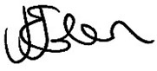
Clerk/Responsible Financial Officer

